**Function constructor**

Function constructor are functions defined by using **new** keyword and **Function()** constructor (**note:** Function with capital F character).

**Syntax:**



**Example 1:** on constructor function without parameters, without returning value.



**Example 2:** on constructor function with parameters, and returning value.

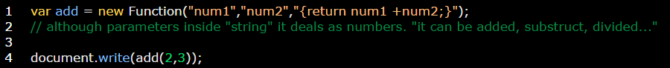

**Example 3:** on How to continue string to the next line using \

